BRAZIL

Creating table sid_brazil.

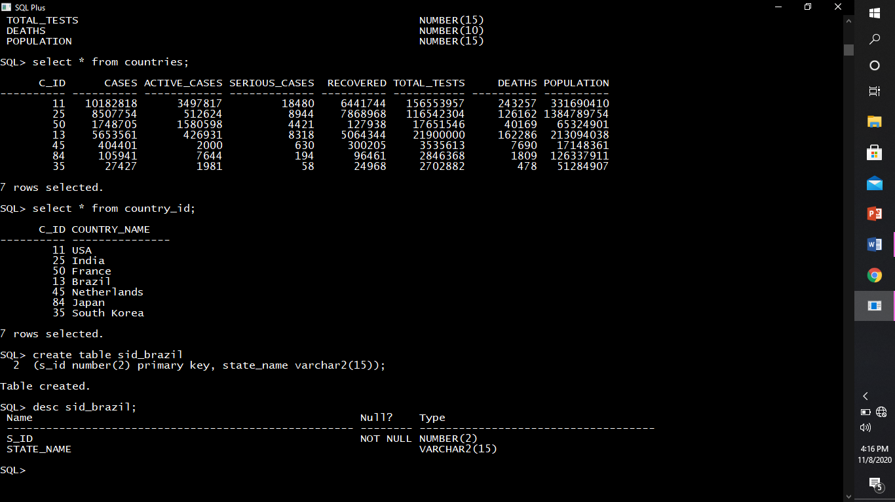

Describing structure of sid_brazil.



Inserting rows into sid_brazil.

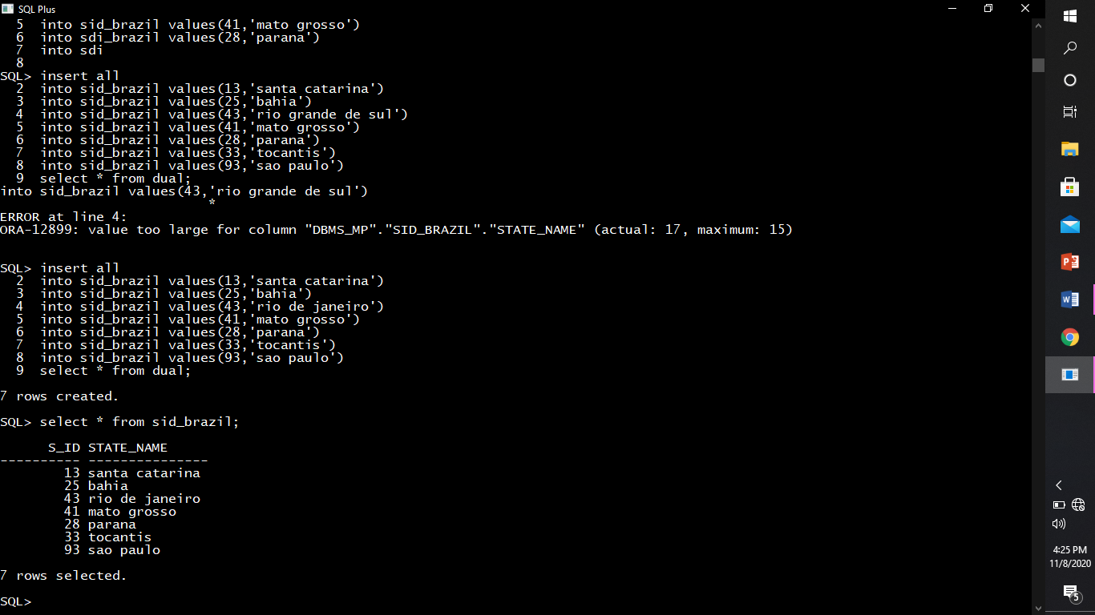

Creating table brazil_states.

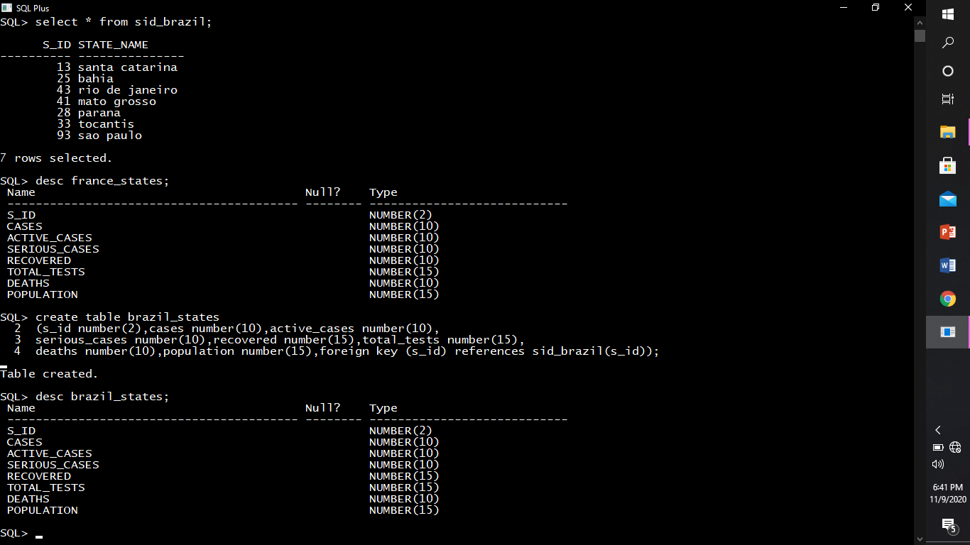

Describing structure of brazil_states.



Inserting rows into brazil_states.

